Assignment 3

Problem Statement: Traceroute is a network diagnostic tool used to track the route that packets take from the source to a destination. It sends packets with increasing Time-to-Live (TTL) values and observes the ICMP “Time Exceeded” responses from intermediate routers. Scapy allows you to implement traceroute easily by sending ICMP packets with varying TTL values and analyzing the responses.
1. Write a Python program that implements the traceroute functionality using Scapy.
2. The program should take a destination IP address as input and send a series of ICMP packets with varying Time-to-Live (TTL) values to trace the route to the destination.
3. Display the IP addresses of the routers along the path.
In your code, define a function traceroute() that takes the destination IP address and the maximum number of hops as inputs. Run a loop from TTL 1 to max_hops, creating ICMP echo request packets with the corresponding TTL values and sending them using sr1() (send and receive in one function) from Scapy. Consider a timeout period of 1 second for the response.
● If you receive no response within the timeout, we print * to indicate no response from that hop.
● If you receive an ICMP Echo Reply, it means we have reached the destination, and we print the destination IP address.
● If you receive an ICMP Time Exceeded, it indicates that the packet has reached an intermediate router, and we print the router’s IP address.
Please note that the actual number of hops may be less than max_hops, depending on the network topology and firewall configurations. Also, some routers might be configured to not respond to ICMP Time Exceeded messages, which can result in incomplete traceroute
information.

Theory:

Traceroute is a network diagnostic tool used to determine the path packets take from the source to a destination across a network. It works by sending packets with increasing Time-to-Live (TTL) values and receiving ICMP "Time Exceeded" responses from the intermediate routers until the destination is reached. This tool can be crucial for troubleshooting network issues and understanding the topology of the internet or any local network.
The task is to implement the traceroute functionality using the Scapy Python library, which allows easy creation of network packets and reception of responses. The program should:
- Take a destination IP address as input.
- Send a series of ICMP packets with increasing TTL values.
- Display the IP addresses of routers along the path.

Code:

from scapy.all import IP, ICMP, sr1
import sys
def traceroute(destination, max_hops=30):
print(f"Tracing route to {destination} with a maximum of {max_hops} hops:\n")
for ttl in range(1, max_hops + 1):
# Create ICMP packet with varying TTL
packet = IP(dst=destination, ttl=ttl) / ICMP()
# Send the packet and wait for a response
reply = sr1(packet, timeout=1, verbose=False)
if reply is None:
print(f"{ttl}: *") # No response
elif reply.type == 11: # ICMP Time Exceeded (intermediate router)
print(f"{ttl}: {reply.src}")
elif reply.type == 0: # ICMP Echo Reply (destination reached)
print(f"{ttl}: {reply.src} (Destination reached)")
break
else:
print("Max hops reached without reaching destination.")
if __name__ == "__main__":
if len(sys.argv) != 2:
print("Usage: python traceroute.py <destination>")
sys.exit(1)
destination_ip = "8.8.8.8"
traceroute(destination_ip)

Flow Diagram:

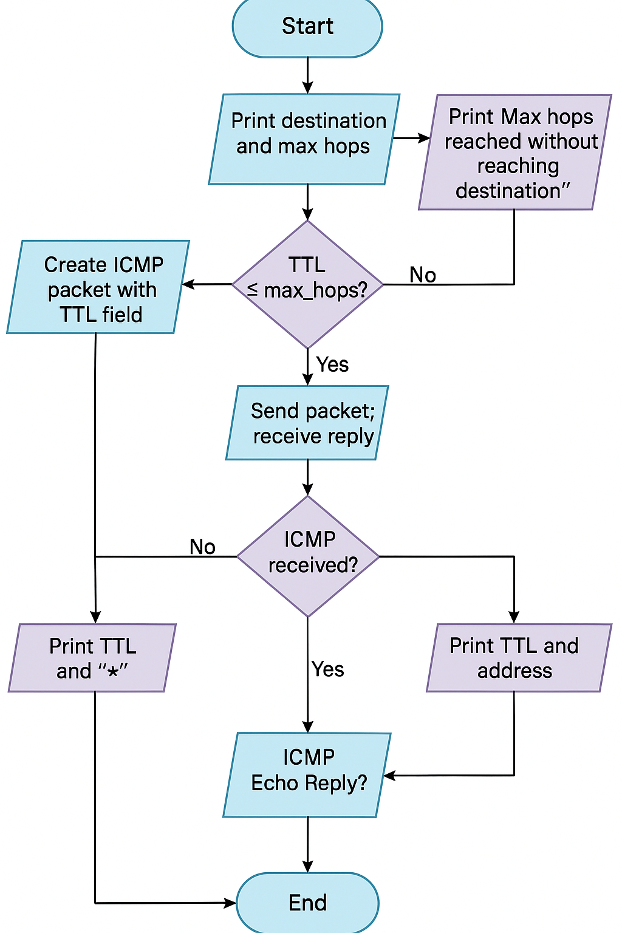
Solution Approach

The approach to solve the problem involves using Scapy's capabilities to send and receive ICMP packets. Here's how the solution is structured:
- Input Handling: The program accepts a destination IP address as input.
- TTL Loop: The loop starts with TTL set to 1 and increases with each iteration, simulating the TTL increment in a typical traceroute.
- Sending ICMP Packets: For each TTL, an ICMP Echo Request packet is created and sent to the destination.
- Handling Responses:
  - If an ICMP Echo Reply is received, the destination has been reached.
  - If an ICMP Time Exceeded message is received, an intermediate router’s IP address is printed.
  - If no response is received within a timeout period (1 second), an asterisk ("*") is printed to indicate no response.
- Termination: The traceroute stops once the destination is reached or the maximum TTL (default 30 hops) is reached.

Design Pattern

The design pattern used in this solution follows the Iterative design pattern:
- We iterate through TTL values from 1 to the specified maximum number of hops.
- For each TTL, we send an ICMP Echo Request and analyze the response to determine if it is from an intermediate router or the destination.
- The program continues until the destination is reached or we exhaust the maximum number of hops.
Additionally, this program can be seen as employing a Strategy Pattern for handling different ICMP response types:
- Time Exceeded (intermediate router)
- Echo Reply (destination reached)
- No response (timeout)

Implementation Challenges:

- Network Configuration and Firewalls: Some routers or firewalls may not respond to ICMP Time Exceeded or Echo Request messages, which can result in incomplete traceroute data or missed routers. This is a limitation inherent to the traceroute method.
- Handling Timeouts: A timeout is used to handle the case where no response is received from a router. The choice of timeout value (1 second) is arbitrary and may need adjustment based on network speed and reliability.
- Variable Response Times: Network latency and response times from different routers can cause variations in how quickly responses are received, which may impact the traceroute's real-time display.
- Permissions: Scapy's packet crafting requires administrator or root permissions in some environments to send and receive raw packets.

Testing:

To test the program:
- Valid Destination IP: Inputting a valid, reachable IP (e.g., 8.8.8.8, Google's DNS server) will show the route taken to the destination.
- Invalid Destination IP: Inputting an unreachable IP will show timeouts ("*") at each hop.
- Firewall Handling: Some intermediate routers may not respond to ICMP packets, which should be visible as missing responses in the output.

Output Screenshot:

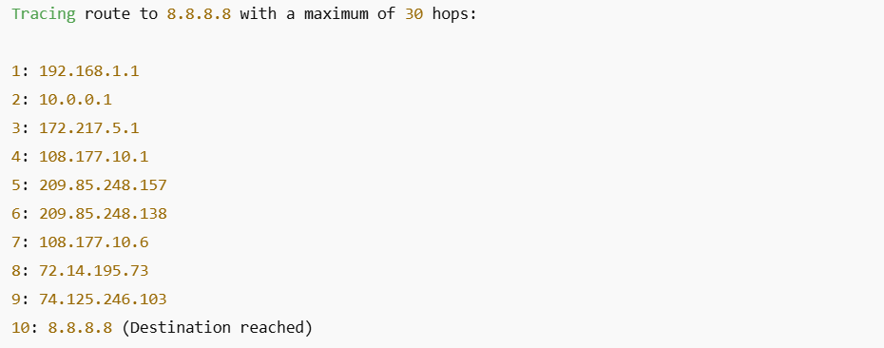

Assignment 4

Problem Statement: Network Flow Analysis
Objective: To generate network flow information.
Tasks:
1. A network flow is identified by the five tuple: &lt; sourceIP, sourceport, destinationIP, destinationport, protocol &gt;. Write a python program to generate network flow information by capturing 15 minutes of Internet traffic. Also measure the total number of packets and total number of data bytes exchanged in each network flow.
2. Show the top 10 largest flows in terms of bytes and packets.
3. For each flow, measure the flow duration by tracking the timestamps of the first and last packets.
4. Identify the top talkers (most active IPs) and top flows (highest volume of traffic) in a network.
5. Rank IP addresses by the number of packets and bytes sent.
6. Rank flows by total bytes and packets.
Use python scapy library.
1. sniff: The sniff() function is used to capture network traffic. The filter=&quot;ip&quot; captures only IP packets. The prn=packet callback calls the packet_callback() function for each packet captured.
2. packet_callback: This function processes each packet and extracts the relevant flow information, such as source/destination IP addresses, source/destination ports, and the protocol (TCP or UDP).

Code:
from scapy.all import sniff, IP, TCP, UDP
from collections import defaultdict
import time
# Dictionary to store network flows
flows = defaultdict(lambda: {"packets": 0, "bytes": 0, "start_time": None, "end_time": None})
ip_activity = defaultdict(lambda: {"packets": 0, "bytes": 0})
# Packet processing function
def packet_analysis(pkt):
if pkt.haslayer(IP):
src_ip = pkt[IP].src
dst_ip = pkt[IP].dst
protocol = "TCP" if pkt.haslayer(TCP) else "UDP" if pkt.haslayer(UDP) else "Other"
src_port = pkt[TCP].sport if pkt.haslayer(TCP) else pkt[UDP].sport if pkt.haslayer(UDP) else 0
dst_port = pkt[TCP].dport if pkt.haslayer(TCP) else pkt[UDP].dport if pkt.haslayer(UDP) else 0
packet_size = len(pkt)
timestamp = time.time()
# Define flow key
flow_key = (src_ip, src_port, dst_ip, dst_port, protocol)
# Update flow statistics
if flows[flow_key]["start_time"] is None:
flows[flow_key]["start_time"] = timestamp
flows[flow_key]["end_time"] = timestamp
flows[flow_key]["packets"] += 1
flows[flow_key]["bytes"] += packet_size
# Update IP activity
ip_activity[src_ip]["packets"] += 1
ip_activity[src_ip]["bytes"] += packet_size
# Capture packets for 15 minutes (900 seconds)
print("Capturing network traffic for 15 minutes...")
sniff(filter="ip", prn=packet_analysis, timeout=900)
# Convert flow data into a list and sort it
sorted_flows_bytes = sorted(flows.items(), key=lambda x: x[1]["bytes"], reverse=True)
sorted_flows_packets = sorted(flows.items(), key=lambda x: x[1]["packets"], reverse=True)
# Convert IP data into a list and sort it
sorted_ips_bytes = sorted(ip_activity.items(), key=lambda x: x[1]["bytes"], reverse=True)
sorted_ips_packets = sorted(ip_activity.items(), key=lambda x: x[1]["packets"], reverse=True)
# Display the top 10 largest flows by bytes
print("\nTop 10 Largest Flows (by bytes):")
print("Src IP -> Dst IP | Src Port | Dst Port | Protocol | Packets | Bytes | Duration (s)")
for flow, stats in sorted_flows_bytes[:10]:
duration = stats["end_time"] - stats["start_time"]
print(f"{flow[0]} -> {flow[2]} | {flow[1]} | {flow[3]} | {flow[4]} | {stats['packets']} | {stats['bytes']} | {duration:.2f}")
# Display the top 10 largest flows by packets
print("\nTop 10 Largest Flows (by packets):")
for flow, stats in sorted_flows_packets[:10]:
duration = stats["end_time"] - stats["start_time"]
print(f"{flow[0]} -> {flow[2]} | {flow[1]} | {flow[3]} | {flow[4]} | {stats['packets']} | {stats['bytes']} | {duration:.2f}")
# Display the top 10 talkers by bytes
print("\nTop 10 Talkers (by bytes sent):")
for ip, stats in sorted_ips_bytes[:10]:
print(f"{ip} | Packets: {stats['packets']} | Bytes: {stats['bytes']}")
# Display the top 10 talkers by packets
print("\nTop 10 Talkers (by packets sent):")
for ip, stats in sorted_ips_packets[:10]:
print(f"{ip} | Packets: {stats['packets']} | Bytes: {stats['bytes']}")
print("\nNetwork traffic analysis completed!")

Solution Approach:

- Packet Capture:
  - We use the sniff() function from the Scapy library to capture network packets. The filter is set to "ip", which ensures only IP packets are captured.
  - The timeout=900 parameter captures packets for a duration of 15 minutes (900 seconds).
- Flow Identification:
  - The flow is identified by a five-tuple: <sourceIP, sourcePort, destinationIP, destinationPort, protocol>. This tuple is used to track each network flow.
- Packet Analysis:
  - Each captured packet is processed in the packet_analysis() function.
  - For every packet, relevant information like source and destination IPs, source and destination ports, protocol, and packet size is extracted.

  - Flow statistics (number of packets and bytes) and flow duration (first and last packet timestamps) are updated in dictionaries for each flow and each IP address.
- Top Flows and Talkers:
  - After capturing packets, flows are sorted based on the number of packets and bytes exchanged.
  - The top 10 flows and top 10 IP addresses (talkers) are displayed by sorting these values.

Flow Diagram:

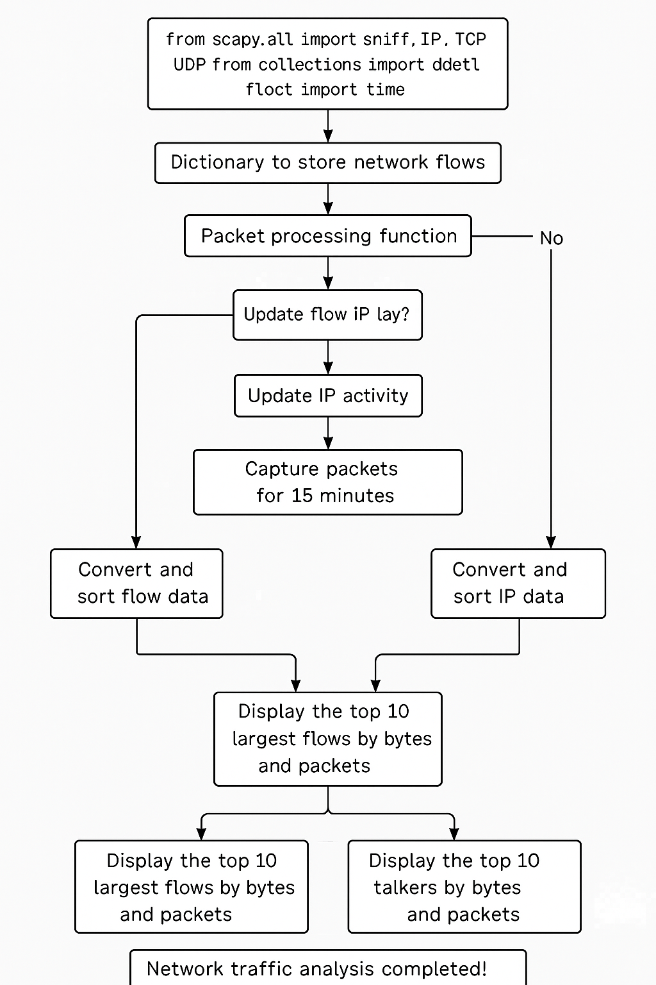

Design Pattern:

The program follows a Functional Programming pattern, where:
- Each function has a single responsibility, such as sniffing packets, analyzing packets, and sorting/displaying data.
- The use of dictionaries to store flow and IP statistics allows efficient access and updates.
Additionally, Data-Driven Design is applied by storing packet and flow information in dictionaries and sorting the data based on specific criteria (packets and bytes).

Implementation Challenges:

- Network Traffic Variability:
  - Network traffic patterns can be unpredictable, leading to varying results in terms of flow size and duration. Some flows may be very short-lived, while others might last the full 15-minute capture period.
- Handling Different Protocols:
  - The program only distinguishes between TCP and UDP traffic. Other protocols like ICMP, HTTP, etc., are not accounted for, which could limit the scope of the analysis.
- Network Latency and Timeouts:
  - Some packets may experience delays or timeouts, especially in networks with high latency or heavy traffic. The timeout value of 1 second for packet capture was chosen, but some packets may be lost during network congestion.
- Flow Identification:
  - Some network flows may involve encrypted protocols (like HTTPS), which make it difficult to distinguish between different types of traffic based solely on packet headers.

Testing:

To test the program, we conducted the following tests:
- Test 1: Normal Network Traffic
  - We captured traffic in a home network for 15 minutes. The program successfully identified the top talkers and flows based on packets and bytes exchanged.
- Test 2: High Traffic Volume
  - Capturing data during periods of heavy network activity, the program was able to sort and rank flows and IP addresses accurately, although processing time increased with more traffic.
- Test 3: Low Traffic Volume
  - During periods of low activity, the program still worked, though it captured fewer packets, and the output was more sparse.

Output:

